Java

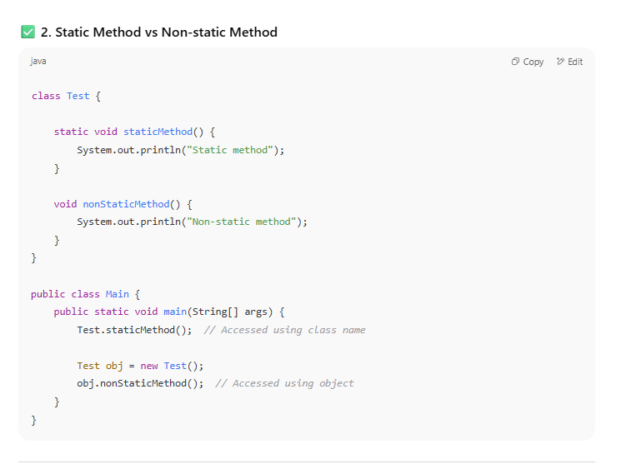

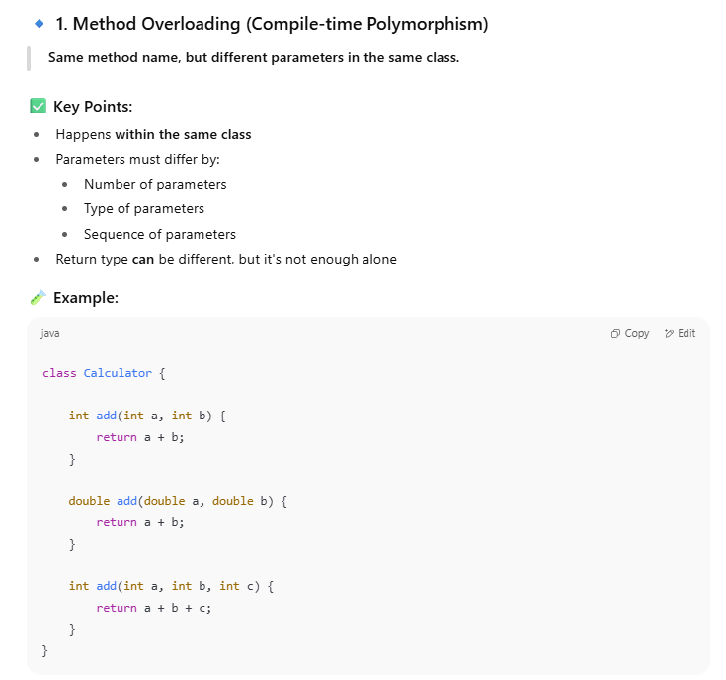

**✅ 2. Abstraction**

**Definition:** Hiding complex internal implementation and showing only essential features.

🔸 **Usage in Selenium:**

* Only exposing methods like login(), clickSearch(), addToCart() while hiding the WebDriver details.
* Page Object Model and utility classes use abstraction to simplify test scripts.
* A screenshot of a computer program

  AI-generated content may be incorrect.
* ✅ **Why it’s abstraction:** Testers use login() without knowing the element IDs or interactions inside.

✅ **Why it’s inheritance:** The child class reuses methods from the parent BaseTest class.

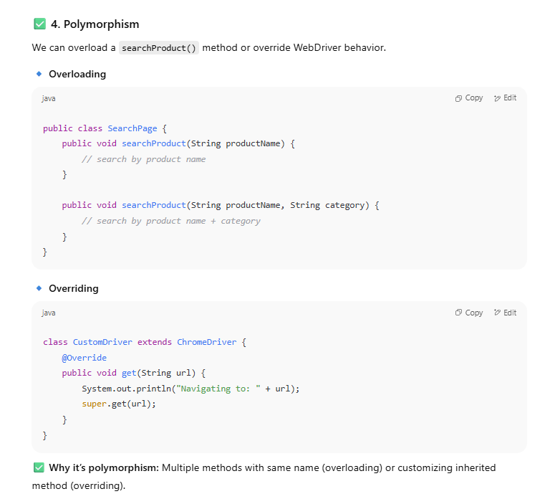

**✅ What is Compile-Time and Run-Time Exception in Java?**

In Java, **exceptions** are unexpected events that disrupt the normal flow of a program. These are categorized into:

**🔷 1. Compile-Time Exceptions**

(Also called: **Checked Exceptions**)

These exceptions are **checked by the compiler** during compilation.  
You must **handle them using try-catch** or declare using throws, or the program won’t compile.

**✅ Examples:**

* IOException
* FileNotFoundException
* SQLException
* ClassNotFoundException

**🔶 2. Run-Time Exceptions**

(Also called: **Unchecked Exceptions**)

These exceptions occur **while the program is running**, and are **not checked at compile time**.  
They are mostly due to **logic errors or bad input**.

**✅ Examples:**

* NullPointerException
* ArithmeticException
* ArrayIndexOutOfBoundsException
* NumberFormatException

**✅ Difference Between Abstract Class and Interface in Java**

Both **abstract classes** and **interfaces** are used to achieve **abstraction** in Java — but they have key differences in syntax, purpose, and usage.

**✅ What is super in Java?**

The super keyword in Java is used to **refer to the immediate parent class** of the current object. It's especially useful in **inheritance** when child classes need to access parent class members.

**✅ What is ArrayList in Java?**

ArrayList is a **resizable array** (dynamic array) provided by the Java **Collections Framework**.  
It can **store a list of elements** (like an array) but with the advantage that it **can grow or shrink** as needed.

**✅ What is LinkedList in Java?**

A LinkedList is a **linear data structure** from the **Java Collections Framework** where each element (called a node) is connected to the next (and optionally the previous) element.  
Unlike ArrayList, elements in a LinkedList are **not stored in contiguous memory**, making insertions and deletions more efficient.

**✅ What is List and Set in Java?**

In Java, both List and Set are part of the **Collection Framework**, but they serve different purposes and have different behaviors.

**🔷 1. What is List?**

A **List** is an **ordered** collection that:

* Allows **duplicate elements**
* Maintains the **insertion order**
* Supports **indexed access**

**✅ Common Implementations:**

* ArrayList
* LinkedList
* Vector

**🔷 2. What is Set?**

A **Set** is an **unordered** collection that:

* **Does not allow duplicates**
* Does **not guarantee insertion order** (except LinkedHashSet)
* Is **faster** for search operations (in some cases)

**✅ Common Implementations:**

* HashSet (no order)
* LinkedHashSet (insertion order preserved)
* TreeSet (sorted order)

**✅ What is the Difference Between == and .equals() in Java?**

In Java, both == and .equals() are used to **compare values**, but they behave very differently depending on the **data type** (primitive or object).

**🔹 1. == Operator**

**✅ Use:**

* Compares **primitive values directly** (int, char, etc.)
* For **objects**, it compares **references (memory addresses)** — i.e., whether they point to the **same object**

**2. StringBuilder – Mutable (Not Thread-Safe)**

* Used when you want to **modify strings frequently** (e.g., in loops).
* **Faster than StringBuffer** as it has no synchronization overhead.



